CIS 470 Design Specification
Team: | B
Team Members: | Josh Romanelli, Mamie Dent, Rob Decker, Mario Gonzalez
Date: | 05/27/2007
Project Title | WSC eCommerce Site

Scope

System Description
To provide a web site for clients to provide their order information as well as to provide the entire company catalog.

Major Software Functions
Creation, modification, storage, and retrieval of:
Order request information
Catalog information
Purchase order information
User access information
Allowing the client to enter an order request into the database
Allowing the client to retrieve order request information
Allowing the client to update their personal and billing information

Database Description
MS Access to store order, catalog, client, and payment tables.

Design Constraints and Limitations
Time, distance between programmers, and relative inexperience.

Design Description

Data Description
Order information, Client information, and catalog information.
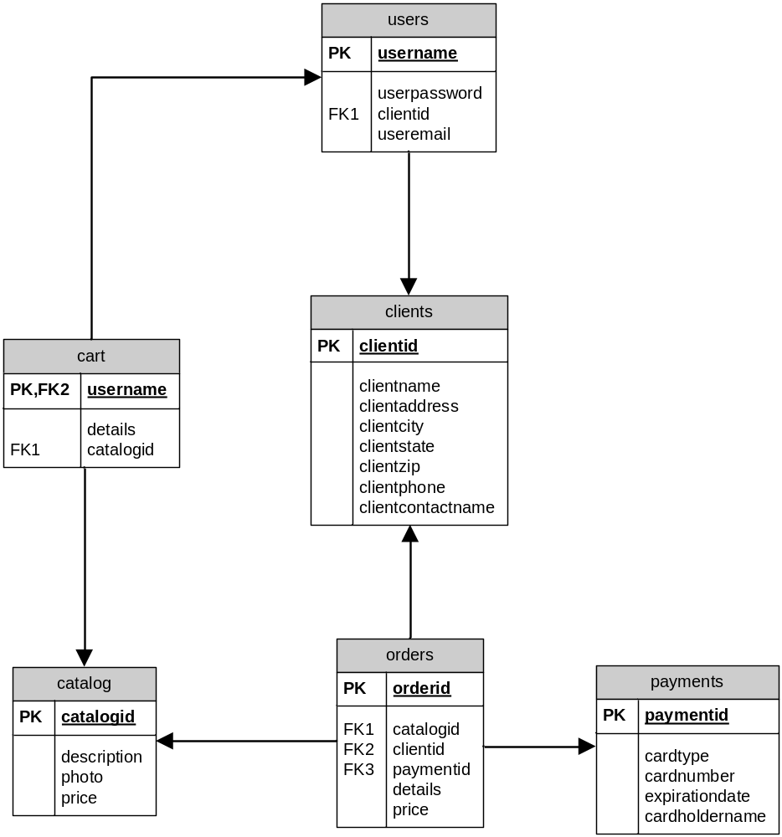

Data Flow
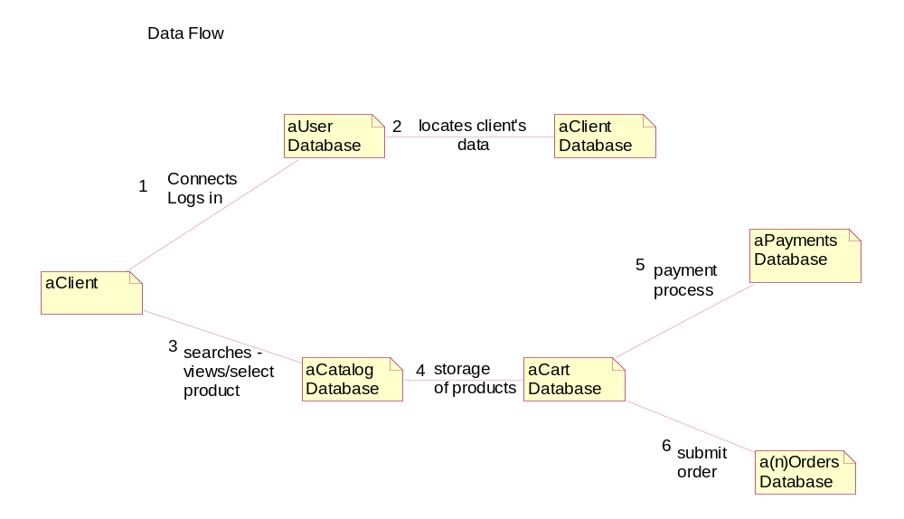

Program Architecture
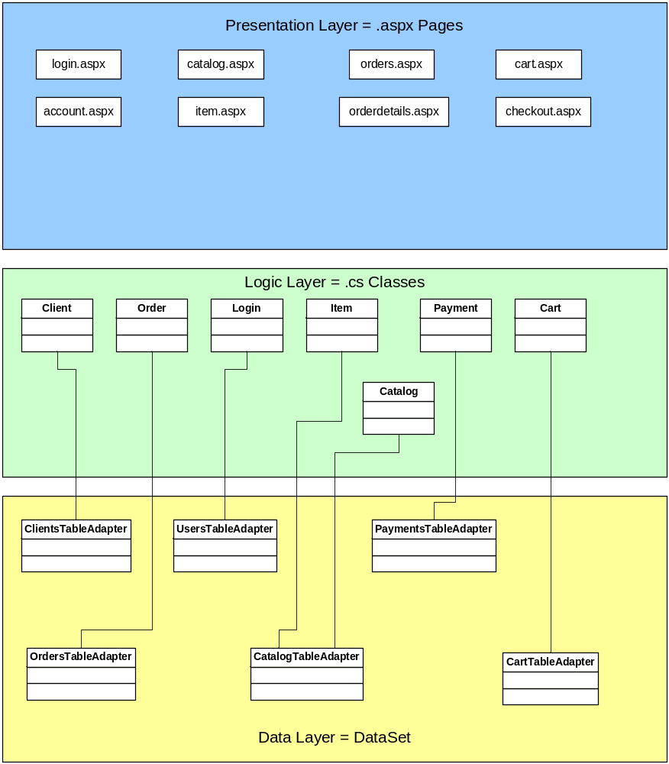

Component Interfaces
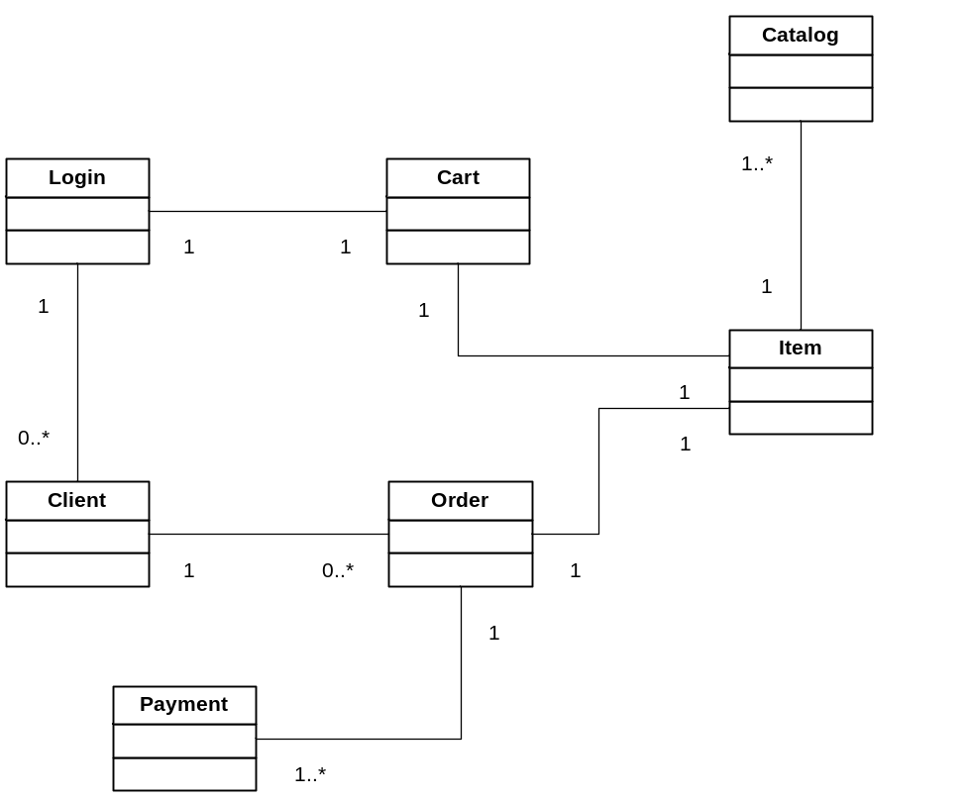

Detailed Design (one section for each component)

Processing Description
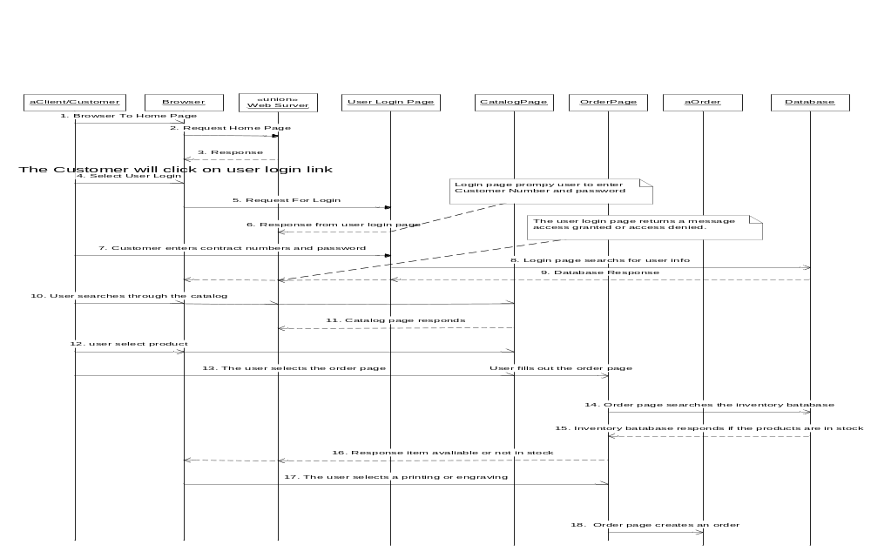
1. The customer enters home page into there browser.
2. The request is sent to the web server.
3. The sever response to the request.
4. The customer clicks the login link.
5. The browser sends the request for login.
6. Login page prompt user to enter Customer Number and password.
7. Customer enters contract numbers and password.
8. Login page searches for user’s login information.
9. The database sends a response. The user login page sends a message prompt. Access granted or denied.
10. User searches through the catalog page for a product.
11. The catalog page responds.
12. The user selects a product.
13. The user selects the order page. The user fills out the order page.
14. The Order page searches the inventory database for products on hand.
15. The Inventory database responds if the products are in stock or not.
16. The order response that an item is available or not in stock.
17. The user selects print or engraving,
18. Order page creates an order

Interface Description
The client will be able to access the order class by logging in via the users class, placing an item from the catalog in the cart, and selecting a payment method.

Modules Uses
The client class is where the user starts. The client class accesses the users class in order to gain access to the site. Once access is granted, the user may select an item from the catalog class, which places the item in the cart class. The client will then want to check out, which he does by accessing the payment class and picking a payment type. The client id, payment id, and catalog id are all placed in the order class, where the item may be purchased.

